

Audio Music RT-1 & RT-2 Manual

Audio Music RT-1 & RT-2
Preamp Instructions
Congratulations on your purchase of the AM Music R-T1/2, reference preamp. The Pre Amplifier is one of the most critical components in any system, and that is why we have gone to such extremes in the design and building of this amplifier. The RT-1/2 is the culmination of 14 years of research and development, where nothing has been omitted, or included, that could possibly interfere with the audio signal.

Firstly, unpack the RT-1/2 from the packaging. It is recommended that the cartons and packaging be kept, if possible, so that the unit is protected in case it needs to be transported in the future.
The RT-1 consists of a power supply chassis and an amplifier chassis. There are no user accessible components in the power supply chassis, and it operates at dangerous voltages, and should only be opened by an authorized repair agent.
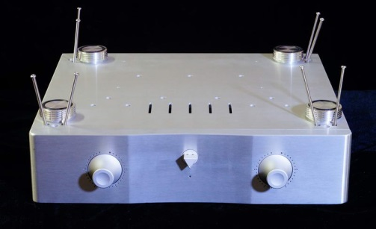
The Amplifier section contains the tubes, and these are pre-installed and secured in place for transportation. No set up is required.
If the tubes need to be replaced.
Place the chassis on a firm surface upside down, and remove the eight screws as shown in the diagram. A Phillips Head Screwdriver will be required.

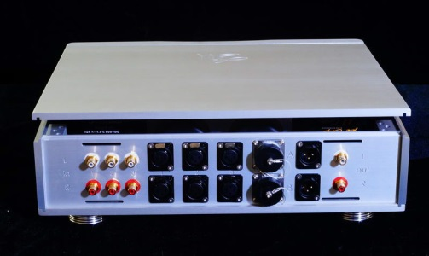
Hold the top in place whist you turn the unit over onto its feet, and carefully remove the top plate which is surprisingly heavy.

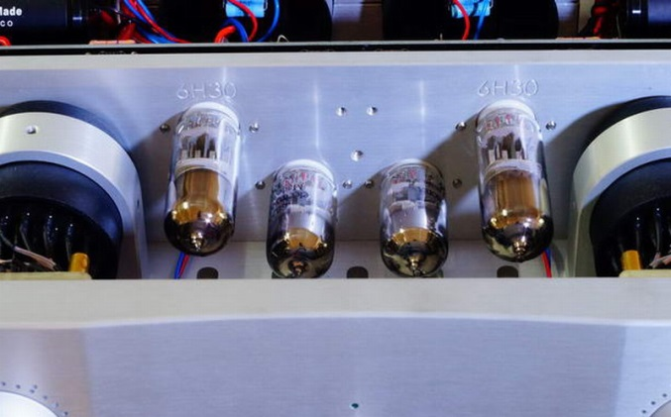
Insert the tubes in the correct position, as marked.

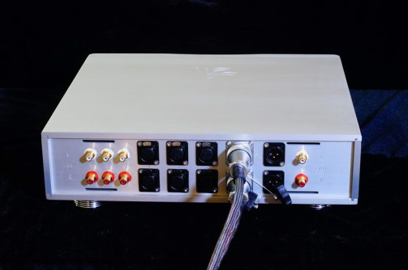
Connect the two cables between the Power Supply and the Amplifier section. Connect the cable to Plug A on both units and the second cable to Plug B on both units. There are several guides on the plugs; one is much thicker than the others. The thick guide is always to the top of the plug.

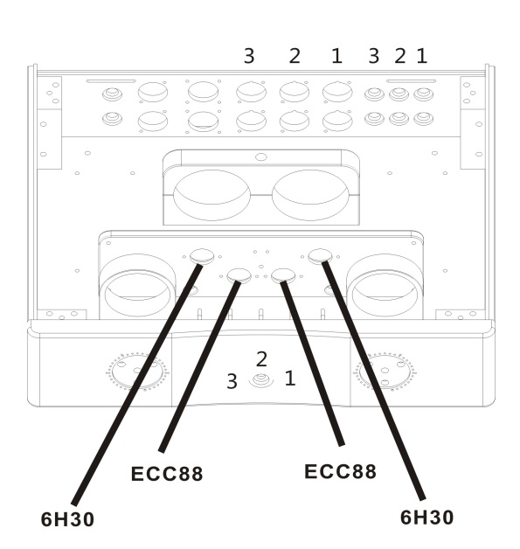
Ensure that the tubes are inserted as per the diagram.
Note the 3 input positions on the central selector knob. Turn the knob as far as it will go clockwise and that is Input 1. Central position is Input 2 and as far as it will go anticlockwise is Input 3. These positions will select either the balanced or line input.

The warranty on all valves is 3 months from date of purchase. Usually, if a valve lasts 3 months, it will last its normal service life.

SAFETY INSTRUCTIONS

To avoid personal injury or damage to equipment, please ensure that you read this manual in its entirety before attempting to operate the equipment. Please retain this manual for future reference.
TO PREVENT THE RISK OF ELECTRIC SHOCK, DO NOT UNDER ANY
CIRCUMSTANCES REMOVE ANY PARTS OF THE EQUIPMENT COVER. THERE ARE NO
USER SERVICEABLE PARTS INSIDE. ALL SERVICING MUST BE CARRIED OUT BY QUALIFIED SERVICE PERSONNEL.
WARNING: Do Not Disassemble Do not attempt to service the equipment beyond that described in this manual. Touching the equipment’s internal parts could result in severe personal injury. All other servicing or problems as listed below should be referred to qualified AM service technicians:
* The power supply cord or plug has been damaged
* Objects have fallen or liquid has been spilled into the equipment
* The equipment does not appear to function normally or exhibits a marked change in performance.
* The equipment has been dropped or the enclosure damaged. Do not under any circumstances allow anyone to modify your AM equipment without first checking with AM, your dealer, or your distributor. Unauthorized modifications will invalidate your guarantee.
Power Source: The equipment should be connected to a power supply only of the type described in this manual or as marked on the equipment.
* Power supply cords should be routed so that they are not likely to be walked on or pinched by items placed upon or against them, paying particular attention to cords and plugs, and the point where they exit from the amplifier.

Ventilation: The equipment should be situated so that its location or position does not interfere with its proper ventilation. These units generate quite a lot of heat. Poor ventilation could/will result in overheating and equipment failure.
* The equipment must not be placed on bed, sofa, or similar surfaces that may block the
ventilation openings.
* The equipment must not be placed in a built-in installation, such as a bookcase or cabinet that may impede the flow of air.
* The equipment should be situated away from heat sources such as radiators, heat register, stoves, or other electronic appliances that produce heat. This equipment is not intended for commercial use.
Water and Moisture: The equipment should not be used near water, e.g. near a bathtub, washbowl, kitchen sink, laundry tub, in a wet basement, or near a swimming pool etc. Similarly, do not placed objects filled with liquid, such as vases on top of the equipment.

Lightning: All hi-fi system can be damaged by lightning. Power amplifiers are particularly at risk and therefore should be turned off when there is risk of lightning strike. For complete protection all mains plugs should be disconnected when not in use.
Cleaning: Never clean with furniture polish, benzene, or volatile liquids. Dust periodically with a clean, soft paint brush. Fingerprints or other marks can be removed with a moist polishing cloth.

Tube compliment | Two 6H30 as the drivers, two 6922 as the amplifiers
Frequency response | 20 Hz ~ 100 KHz
Input Impedance | 47k ohms variable, depending on the source
Volume control | 33 position volume control
Output impedance | 600 ohms. RCA and Balanced outputs
Input selections | 3 pairs of RCA single ended. #pairs balanced/XLR
Gain | Input 0.5V, output 2.5V
S/N | >98dB
Distortion | Less than 0.5% @ 5V
Power Consumption | 45 Watts
Dimensions (W-D-H) | 380 X 340 X 110mm
Weight | 38Kg shipping weight

Warranty:
The warranty on all AM products is two years parts and labor. The amplifier must be returned to the factory, or to the dealer from which it was purchased, or to a repairer authorized by the factory or the dealer. The warranty on tubes is 3 months from purchase. If a tube lasts 3 months, then it is most likely to last the normal life cycle.
Please contact your dealer if you have any other questions or if you would like any information on other AM products.
AM wishes you many years of very happy listening. Thank you.

